__________________

**Set-2 Teacher’s Initial**

**Class Test No.: 02 Semester:**

**ID Number: Course Title:**

**Course Code: Date:**

Time: 30 mins Total Marks: 15

**PART A**

1. **Answer the questions within two sentence (2*2=4)**
   1. How many ways CSS can be included in HTML? Give example.
   2. How many screen size generally considered for Responsive Web Design? Describe in brief with necessity.

**Ans:**

Devices Size

Phones 480px and below

Phones to Tablets 767px and below

Portrait Tablets 768px and above

Net Book 990px to 1024px

Monitor 1024px and above

**PART B**

Suppose the Department of Software Engineering, DIU is organizing a study tour for the students of SWE Department, Main Campus. Students who have completed at least 12 credits are eligible to register for the tour. For that purpose, the department is planning to develop an online assessment system which will check if a student is eligible or not. In order for that the system will ask little information to the students, same as the diagram given below:

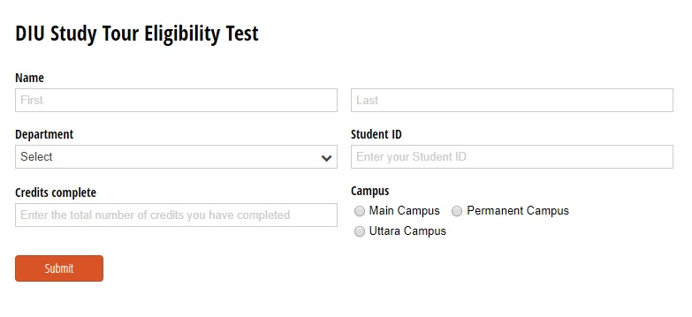

1. See the structure carefully and write the HTML and CSS **(6)**
2. Show that if a student doesn’t provide valid information to a field, there shows a warning message. **(3)**

**(For every <input> tag the required attribute and type must be written accurately)**

1. Using JS show pop-up: **(2)**
2. “Congratulations! You are eligible for the registration.”- To the students who meet the criteria.
3. “Unfortunately, you are not eligible for the registration.” - To the students who fail to meet the criteria.

In HTML

<form name=”myform”>

<input type=”text” name=”credit”>

or

<input type=”text” id=”crdt”>

Code.js:

function validateInfo(){

var credit = document.forms[“myform”][“credit”].value;

or

var credit = document.getElementById(“crdt”).value;

if(credit <15){

alert(“Unfortunate,you are not eligible”);

return false; //for document.form

}

else{

alert(“Congratulations, you are eligible ”);

return true; //for document.form

}

}

< button type=”submit” onclick=”return validateInfo()” value=”submit”>

//for document.form return is needed

//for document.getElementById return not needed